Risk Profiler

Data By:

Area Scenario Training Download About Contact

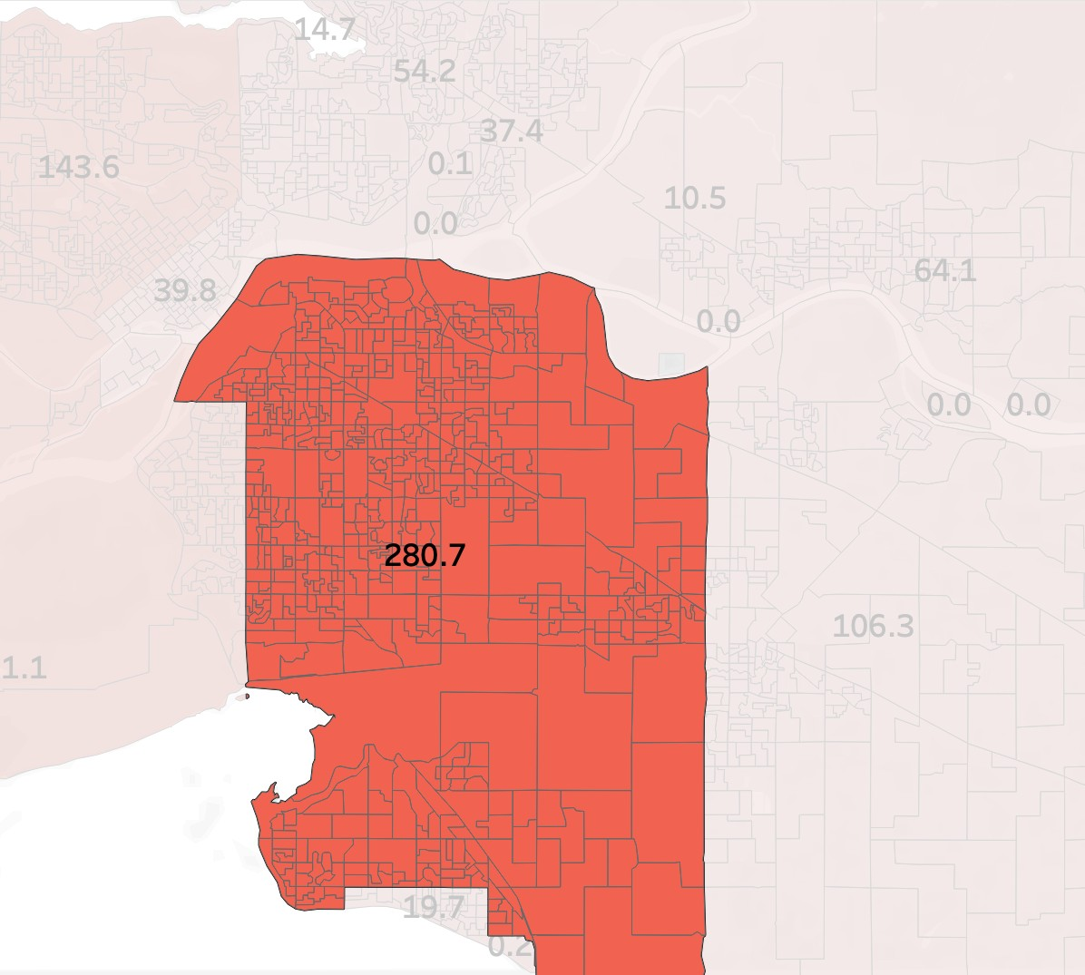

or View List

**Municipality Name**

Reset

Go

Search By Metro Region or Municipality

**+**

**-**

Back to:

Scenario Catalogue

New? Take The Tour

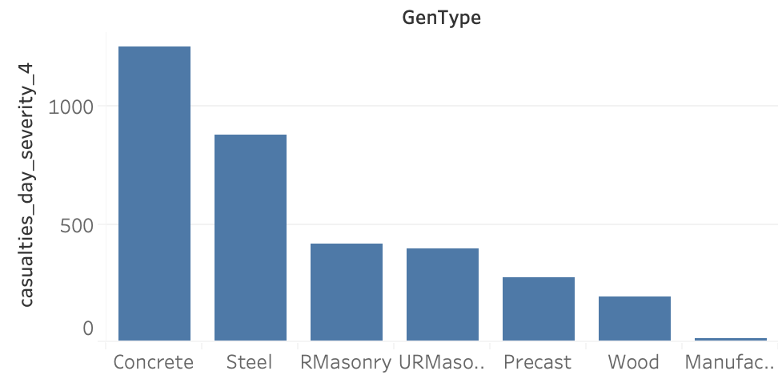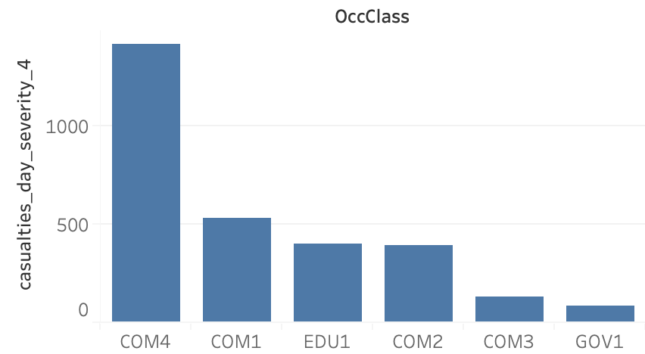

Footer

**Scenario Name: Mw 9.0 Cascadia Interface**

This is a moment magnitude 9.0 earthquake on the Cascadia Subduction Zone. Earthquakes like this occur about once every 400-500 years, with the most recent event in January 1700."

**Municipality Name**

**Deaths: 2342 of 23423 for Scenario Damage: 23412 for Scenario Dollars: $23232 for Scenario**

Select indicator:

Fatalities

